[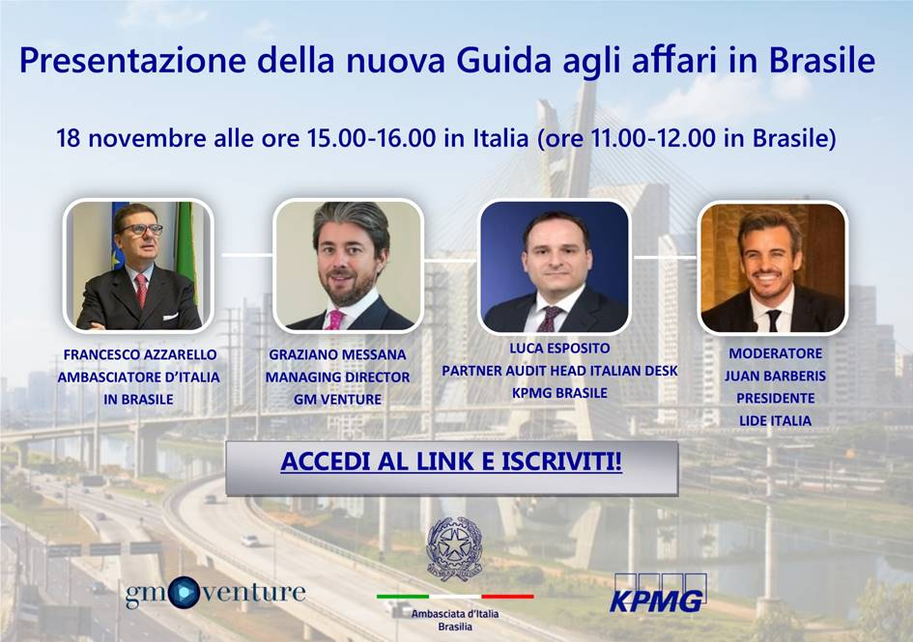](https://kpmgbrasil.webex.com/mw3300/mywebex/default.do?nomenu=true&siteurl=kpmgbrasil-it&service=6&rnd=0.6370967294265167&main_url=https%3A%2F%2Fkpmgbrasil.webex.com%2Fec3300%2Feventcenter%2Fevent%2FeventAction.do%3FtheAction%3Ddetail%26%26%26EMK%3D4832534b00000004c46a0654dd198bb5e1220fe4dc3e971efc5de881d8c7c5168b53b13b1a402c99%26siteurl%3Dkpmgbrasil-it%26confViewID%3D177454796974887550%26encryptTicket%3DSDJTSwAAAAQKPLsc8kg4fAvQasFTosc3KQReMDSOlzFgLAtoLnQO3A2%26)

**SE HAI DIFFICOLTÀ AD ACCEDERE AL LINK NELLA LOCANDINA, PUOI UTILIZZARE IL SEGUENTE INDIRIZZO:**

https://kpmgbrasil.webex.com/mw3300/mywebex/default.do?nomenu=true&siteurl=kpmgbrasil-it&service=6&rnd=0.6370967294265167&main_url=https%3A%2F%2Fkpmgbrasil.webex.com%2Fec3300%2Feventcenter%2Fevent%2FeventAction.do%3FtheAction%3Ddetail%26%26%26EMK%3D4832534b00000004c46a0654dd198bb5e1220fe4dc3e971efc5de881d8c7c5168b53b13b1a402c99%26siteurl%3Dkpmgbrasil-it%26confViewID%3D177454796974887550%26encryptTicket%3DSDJTSwAAAAQKPLsc8kg4fAvQasFTosc3KQReMDSOlzFgLAtoLnQO3A2%252